Submitted Paper Grading Criteria
Study Design
Only Section Facilitators Score this category
Date last revised: 3/3/21

A goal of the Scientific Review & Editorial Committee (SREC) in choosing papers for the AAEP annual meeting is to combine the best available clinical research with clinical experience and expertise to meet the needs of our patients. Below are the criteria the Section Facilitators will use when scoring Study Design.

The other categories in which each paper is scored, Study Quality, Innovation & Impact, Practicality, and Manuscript Quality, can be found in a separate document.

Please keep in mind that Scientific papers, How-to papers, and Review papers will be ranked against only papers of the same type.

--------------------------------------------------------------------------------------------------------------------
Study Design
multiplied by a weighting factor of 1. Only Section Facilitators Score this category.

Scientific Papers: 10-point scale

- For papers that utilize a naturally occurring disease or condition model use Flow Chart A below.
- For papers that utilize an experimentally induced disease or condition model use Flow Chart B below.
- To assist identification of the study design category use “Questions to Assist Flow Chart Navigation” and “Definitions for Study Design Categories” below.
- “Other or Miscellaneous Studies” categories are considered scientific papers with their respective point assignments listed under “Questions to assist flow chart navigation” below.
- Reviewers should keep in mind that assessment of how WELL the study was carried out is assessed with the study “quality score”. The study design score is just an assessment of what type of study was performed.

How to Papers: How to papers do not receive a score in the Study Design category.

Review Papers: Review papers do not receive a score in the Study Design category.

Business Papers: Business papers do not receive a score in the Study Design category.

Study Design Flowchart A
Naturally Occurring Disease or Condition Evaluated

Were Controls Used?

YES NO

Randomized Comparative
Non-blinded
<5 cases
5-10 cases
> 10 cases
Blinded
Blinded
Non-blinded
Descriptive Study
Case Studies or Series
Survey
Randomized Comparative
Cohort or Case-Controlled
Prospective Cohort
Retrospective

10 pts 7 pts 8 pts 6 pts 7 pts 6 pts 6 pts 3 pts 1 pt 3 pts

Study Design Flowchart B
Experimentally Induced Disease or Condition Evaluated
Were Controls Used?

YES NO
Randomized Comparative Non-Blinded
Randomized Comparative Blinded
Randomized Comparative Non-Blinded
Randomized Comparative Blinded

8 pts 6 pts 6 pts 4 pts

Note: If the comparative study is not randomized, subtract 2 points.

Questions to Assist Flow Chart Navigation:

- Is the hypothesis or clinical condition in question being evaluated by utilizing a naturally occurring disease/condition model or with an experimentally induced disease/condition model?

If naturally occurring - use Flow Chart A
If experimentally induced - use Flow Chart B
If the submitted paper does not fall into one of the above categories see the "Others Categories" below.

Flow Chart A (naturally occurring disease/condition)

- Are controls used?

If yes - you have four choices:

- If the study is a comparative randomized study that is blinded - 10 points. Note: Comparative studies usually evaluate the efficacy and/or safety of a therapeutic or preventive intervention
- If the study is a comparative randomized study that is not blinded - 7 points
- If the study follows over time, similar groups and evaluates how certain risk factors affect a certain outcome this is likely a prospective cohort study - 8 points
- If the study utilizes medical records to determine how certain risk factors affect a certain outcome this is likely a retrospective cohort or case-controlled study - 6 points

If no - (controls are not used) you have six choices:

- If the study is a comparative randomized study that is blinded - 7 points
- If the study is a comparative randomized study that is not blinded - 5 points
- If the descriptive study is a series of more than 10 case studies - 6 points
- If the descriptive study is a series of 5 - 10 case studies - 3 points
- If the descriptive study is a survey – 3 points
- If the descriptive study is a series of less than 5 case studies - 1 point

Flow Chart B (experimentally induced disease/condition)

3. Are controls used?

If yes - you have two choices:

- If the study is a comparative randomized study that is blinded - 8 points
- If the study is a comparative randomized study that is not blinded - 6 points

If no - (controls are not used) you have two choices:

- If the study is a comparative randomized study that is blinded - 6 points
- If the study is a comparative randomized study that is not blinded - 4 points

4. Other Miscellaneous Scientific Study Categories:

- Meta-analysis - 10 points
- Analytical comparisons of products - 5 points
- Technique or diagnostic test comparisons - 5 points (e.g., x-ray versus MRI for diagnostic accuracy of a certain condition)
- Pharmacokinetic studies - 5 points
- In-vitro studies – 4-5 points

Definitions for Study Design Categories

1. Randomized Comparative Study - These studies evaluate and compare the efficacy and/or safety of a therapeutic or preventive intervention.
2. Observational Epidemiological Studies - These studies test hypothesizes regarding risk and incidence among exposed and unexposed populations.

- Prospective Cohort Study - A study that follows over time, a group of similar individuals (cohorts) who differ with respect to certain factors under study, to determine how these factors affect rates of a certain outcome (that has not yet occurred). See diagram below.
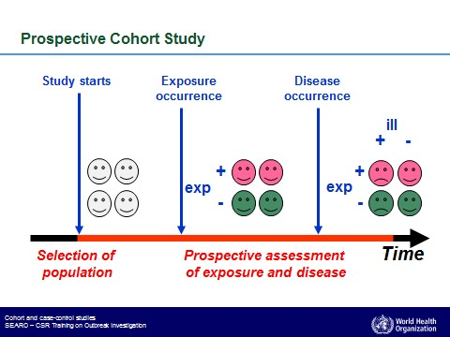
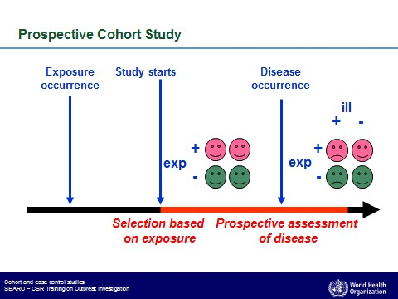
- Retrospective Cohort Study - A study in which the medical records of groups of individuals who are similar but differ by a certain characteristic(s) are compared for particular outcome (that has already occurred). See diagram below.

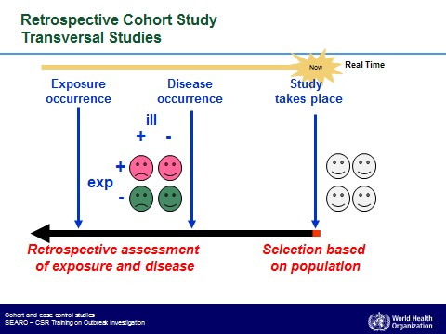

- Case Controlled Study - A study used to identify factors that may contribute to a medical condition/disease by comparing subjects who have that condition (cases) to subjects who do not have the condition (controls). See diagram below.
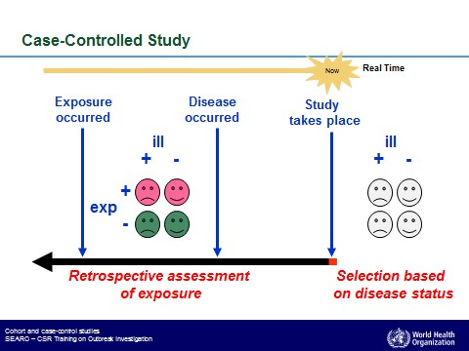

3. Descriptive Study – These studies are used to describe phenomena. They are useful for answering questions related to prevalence or incidence of a disease or condition, or to describe features related to clinical presentation or disease progression and prognosis. Descriptive studies do not have a comparison (control) group and are not appropriate for testing hypotheses related to disease causation, risk factors for disease or efficacy of interventions (Dohoo et al., 2010). The main types of descriptive studies are surveys, case reports and case series."

- Case Study Series - A report of the medical history and outcomes on multiple patients with a specific condition receiving a treatment or diagnostic procedure.
- Case Report or Expert Opinion - A report of the medical history and therapeutic or diagnostic outcome of a single patient or the description/technique for the treatment or diagnosis of a specific condition based on experience and expert opinion.
- Survey - A survey collects information about a group of people or cases by asking them questions and analyzing the results. Surveys can be used in both cross-sectional studies, where you collect data just once, and in longitudinal studies, where you survey the same sample several times over an extended period.

4. Miscellaneous Scientific Studies Categories (those without the utilization of a
therapeutic or preventive intervention)

- Meta-analysis - A statistical, systematic review contrasting and combining results from different studies, in hope of identifying patterns among study results, sources of disagreement among those study results or other interesting relationships that may come to light in the context of multiple studies.
- Analytical Comparisons of Products - For example, these studies may compare the active pharmaceutical ingredient in various compounded products.
- Pharmacokinetic or Pharmacodynamic Studies -
- Technique or Diagnostic Test Comparisons - For example, evaluating the specificity or sensitivity of radiography versus MRI for diagnostic accuracy of a known condition.

