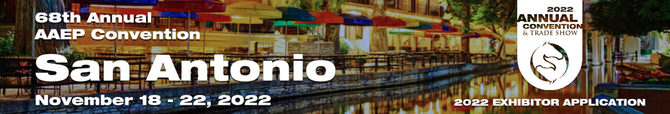
Stable Education- Live Demo/Presentation Areas
Do you have a new product you want to showcase outside your exhibit space? Do you want dedicated time in front of an audience? This year, we have 2 options for you!

- Video Lounge: A quiet, cozy area in the AAEP Connect Area with comfortable seating and charging tables. You create a video that we turn into a QR code. The QR codes will be placed on an individual meter board that will be branded with your company’s graphics and a description of your video. Members can scan the QR code and watch your video at their leisure.
- Demo Theaters: Give a demo in front of a live audience during the lunch break! A chance for companies to present research on a new product, demo equipment or give a sales pitch. Presentation time slots will take place during the lunch break 2 days of the trade show. This is a great way to create buzz for your company, attract more members to your booth and increase sales at the show. Time slots are limited and will be sold/assigned first come, first serve basis.

DEMO THEATERS:
-Demonstrations are limited to 30-minutes (times will be assigned during the lunch breaks Saturday and Sunday)
-1-2 presentation areas will be staged inside the exhibit hall in the food concession area
-Large signage with presentation schedule will be placed strategically
-Standard AV is provided (monitor, Wireless Headphone, Speakers, Stage and Podium)
-Each presenting company must provide a brief description of demonstration

COMPANY INFORMATION:
Company name: _________________________________________________________

Contact: ________________________________________________________________

Phone: ________________________ Email: ________________________________

(See back side for more info)

Description of Video/Demonstration: __________________________________________________________________________________________________________________________________________________________________________________________________________________________________________

Please indicate if you will participate in the Video Lounge or Product Demo Theater or both

Video Lounge ($250) per video: ________ TOTAL $: _________

30 Minute Time Slot ($1200) per time slot: _______ TOTAL $: _________
*Limited to 2 slots per company

Mark preferable time slots: Please note: Final allocation of time slots will be done by the organizer
 | 10:30-11:00 | 11:00-11:30 | 11:30-12:00 | 12:00-12:30 | 12:30-1:00 | 1:00-1:30
Saturday, Nov. 19

Sunday, Nov. 20

*An Invoice will be emailed to you for payment

For internal use
Approved by: | Day Assigned: | Time Slot:

