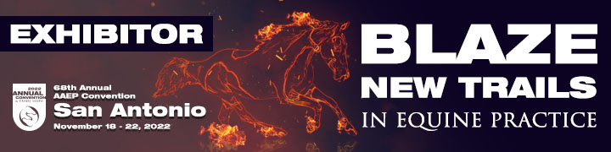

Make your company stand out by including your company logo! The AAEP Convention App and the Live Floor plan located on our website are convenient guides to the convention for both members and exhibitors, before, during and after the convention. Adding your company’s logo will provide more prominence and drive convention attendees to your booth and website during the 68th Annual AAEP Convention in San Antonio, TX, November 19-21.
But we won’t stop at just the App and Live Map! Your logo will also be added to your listing in the Guide to Exhibits section in the Convention Program and over your booth on the large Trade Show map wall. We will have the Large Floor Map placed around the convention center- in the Registration Area, near the session rooms and the entrance to the trade show.

Exhibiting companies can gain these exposures by adding their company logo for only $300.
This is a great opportunity for such little cost. Don’t wait to take advantage of this offer for only $300! Please fill out the form below and return with your company logo in both JPEG and EPS format to dmiles@aaep.org

COMPANY INFORMATION:
Company name: _________________________________________________________
Company Contact: _______________________________________________________
PAYMENT INFORMATION: An invoice will be emailed to you.
Signature: ___________________________________ Date____________________
** The Convention App will be available later this summer and can be downloaded free by users of the iPad, iPhone, Android and Android tablet. Search “AAEP Convention” at your App Store. **

