December 7, 2019 AAEP and ISELP

Stifle & Neck Ultrasound Wet Lab
At Colorado State University’s new
Translational Medicine Institute (TMI Center)

Session One
Registration materials will be disseminated on the bus. If you plan to take alternate transportation, you can pick up materials at TMI upon your arrival.
Program presentations will begin at 8:00 AM

Transportation Will Be Provided
Promptly meet at: _______________________________________________________________________________________________________
BUS WILL DEPART AT EXACTLY 6:30am for the first session and leave promptly at 12:30pm to return to the hotel by 2:00pm.

Session Two
Registration materials will be disseminated on the bus. If you plan to take alternate transportation, you can pick up materials at TMI upon your arrival.
Program presentations will begin at 12:30 PM

Transportation Will Be Provided
Promptly meet at: _______________________________________________________________________________________________________
BUS WILL DEPART AT EXACTLY 11:00am for the second session and leave promptly at 4:30pm to return to the hotel by 6:00pm.

Notes will be provided VIA EMAIL for you to download prior to the event. If you prefer printed material, PLEASE PRINT and
BRING THEM WITH YOU

Coffee & pastries will be available at check in and lunch will be provided
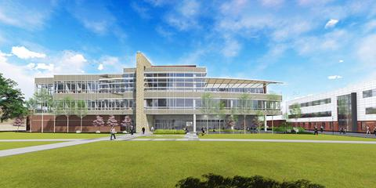

Essential techniques for the ultrasound exam of the Equine Stifle and Neck
Time 8am to 12pm and 12:30pm to 4:30pm
Cost $450 for ISELP or AAEP member
$500 for non-ISELP, non-AAEP member
Attendance 50/session
Coordinators: Kurt Selberg/Kent Allen
Instructors: Myra Barrett, Erin Contino, Sherry Johnson, Elizabeth Acutt, Kent Allen, Russ Peterson, Roland Thaler, Cooper Williams, Jessica Morgan, Duncan Peters

The equine neck and stifle have complex soft tissue and bone anatomy that
is often challenging to image. You will spend the session exploring the pertinent
anatomy and correlative imaging. You will discuss clinical cases with
the instructors and talk about approaches to diagnosing injuries and treating the equine
athlete with clinicians who make a living doing just that. Different conditions are
reviewed including: disease processes of the stifle and neck and key
desmopathies/enthesopathies. The demonstration will also include a neck ultrasound guided injection to familiarize yourself that technique.

Your session will be spent in an intense exploration of ultrasonographic examination of
the equine neck and stifle with specific goals. A group of talented clinicians will assist you in the imaging session with small groups and plenty of time.

Agenda
6:30-8:00 Bus departs at 6:30am and travel to CSU
8:00-9:30 Live Demonstration & Lecture – Anatomy and ultrasound exam of the neck and stifle
9:35-10:30 Wet Lab Station Rotations: ½ participants Neck; ½ participants Stifle
*Participants will review a complete ultrasound exam of the neck and stifle with a check list of specific objectives.
10:30-10:40 Rotate
10:40-11:40 Wet Lab Station Rotations: ½ participants Neck; ½ participants Stifle

11:00-12:30 Second group Bus to CSU
11:40-12:30 Lunch
12:30-2:00 First group conclude/bus back
12:30-2:00 Live Demonstration & Lecture – Anatomy and ultrasound exam of the neck and stifle
2:10-3:10 Wet Lab Station Rotations: ½ participants Neck; ½ participants Stifle
Participants will review a complete ultrasound exam of the neck and stifle with a check list of specific objectives.
3:10-3:20 Rotate
3:20-4:20 Wet Lab Station Rotations: ½ participants Neck; ½ participants Stifle
4:30-6:00 Sessions Conclude/Bus Departure

*Participants will spend 1 hour on the Stifle and 1 hour on the Neck in groups of 5 or less with one imaging clinician and one horse.

