Frequently asked questions:
- You will be judged on overall visual presentation, organization, attention to detail, spelling and grammar, content quality, and scientific accuracy.
- High resolution images are highly recommended.
- Use less long text if possible while still being thorough. Long text becomes very small on printed posters and hard to read.
- Use a mentor or Faculty Advisor for guidance to create outstanding poster.
- You MUST use the attached template when creating your poster.
  - The font and color of text must stay as the template shows below, so all posters are uniform. However, the rest of the grey area is yours to design as you wish; one column or 10, pictures, diagrams, whatever you need to present your case effectively.
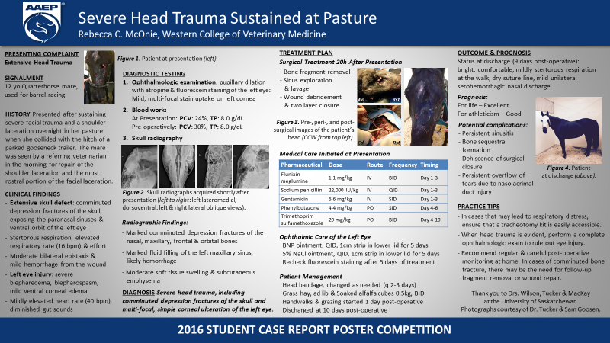
  - See the examples below of previous posters accepted.

